LDT – UK Flight Patterns

The Civil Aviation Authority CAA has published punctuality statistics for flights arriving and departing from UK airports since 1990. These include the start and end airports airline and number of flights per year.

By geocoding these airports is possible to calculate approximate distances and in turn carbon emissions / energy use.

Some initial plots to show early findings, these results are provisional and may include double counting of internal flights. Data for 2018 is presented.

World

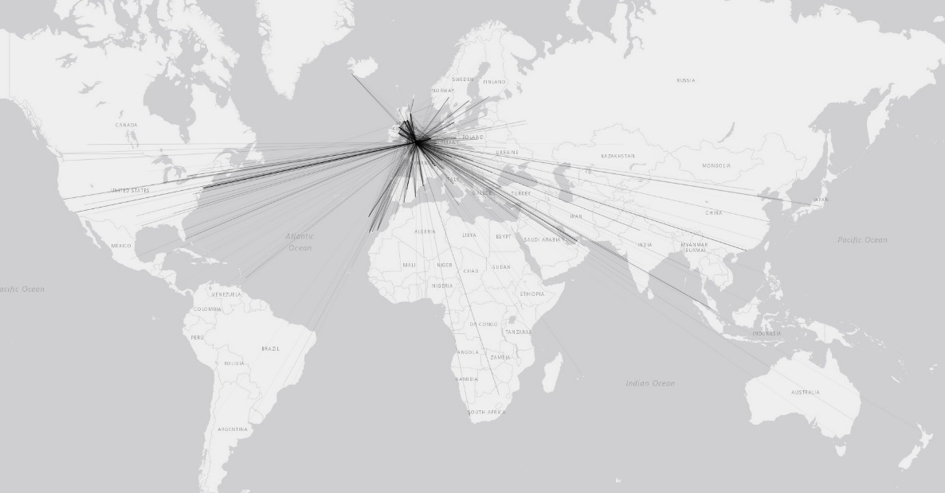

Europe

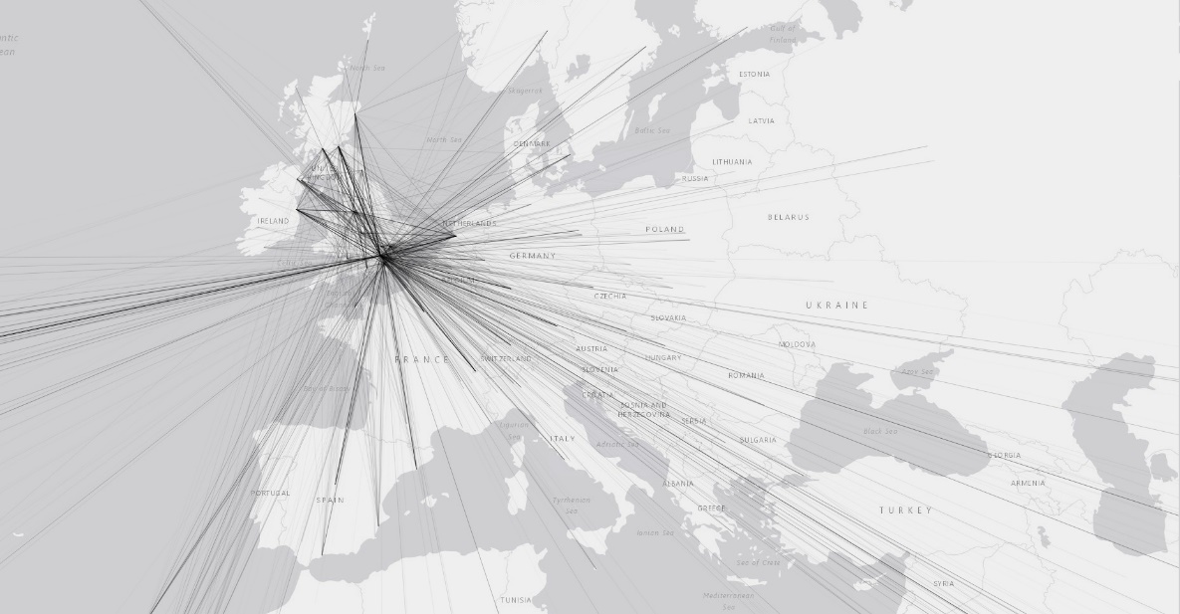

UK

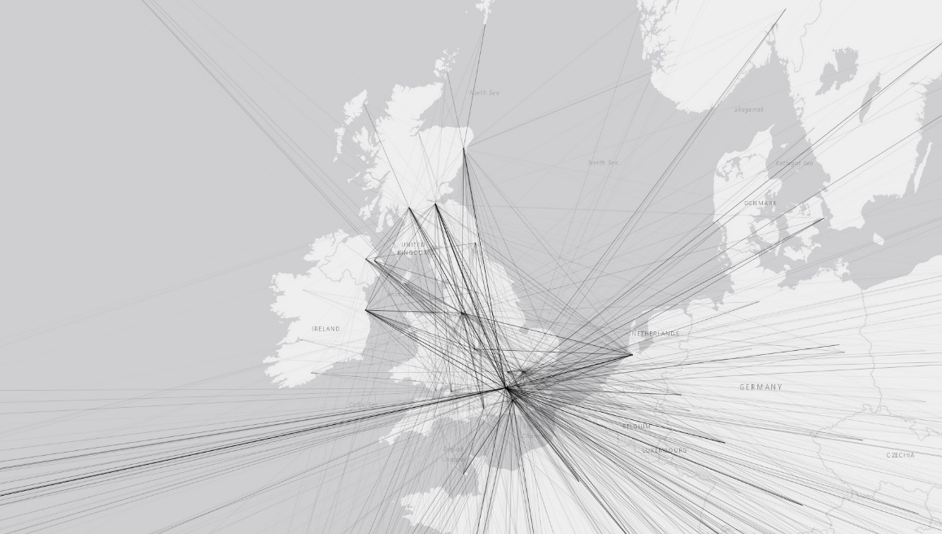

Top Flights In 2018

|  |  |  |  |
| --- | --- | --- | --- |
| Origin | Designation |  | Flights |
| Heathrow | John F. Kennedy International | USA | 13923 |
| Heathrow | Dublin | IRISH REPUBLIC | 13639 |
| Heathrow | Luchthaven Schiphol | NETHERLANDS | 12930 |
| Heathrow | Frankfurt main | GERMANY | 12734 |
| Heathrow | Munich | GERMANY | 10110 |
| Gatwick | Barcelona | SPAIN | 9823 |
| Heathrow | Geneva | SWITZERLAND | 9708 |
| Edinburgh | Heathrow | UNITED KINGDOM | 9704 |
| Heathrow | Edinburgh | UNITED KINGDOM | 9704 |
| Heathrow | Paris (Charles de Gaulle) | FRANCE | 9619 |
| Heathrow | Zurich | SWITZERLAND | 9086 |